
LOGBOOK
STUDENT DETAILS
Student Name: Kon Chol John
Admission Number: BSCCS/2024/33891
Course: Bachelor of Science in Computer Science
Unit Code: BIT4133
Unit Name: Natural Language Processing with Deep Learning
Lecturer: Nyoro Michael
Semester: Year 4 Semester 2

PROJECT TITLE
Sentiment Analyzer System Using Python and

TECHNOLOGIES USED
- Python
- Flask
- TextBlob
- SQLite
- HTML
- CSS
- Visual Studio Code

Github Link: https://github.com/koncholjohn/sentiment-analysis.git

Contents
Introduction to NLP Concepts and Text Processing 1
Activities Performed 1
TECHNOLOGIES USED 1
Fig 1: Python Installation 1
Fig 2: Visual Studio Code Setup 2
Fig 3: Flask and TextBlob Installation 2
Fig 4: Tokenization Output 2
Fig 5: Stop words Removal Output 2
Fig 6: NLP Applications Research 3
Student Reflection 3
WEEK 2: N-GRAM MODELS AND POS TAGGING 3
Language Modeling and Sentence Structure Analysis 3
Required Evidence 4
Fig 1: Bigram Output 4
Fig 2: Trigram Output 4
Fig 3: POS Tagging Example 4
Student Reflection 5
WEEK 3: HIDDEN MARKOV MODELS AND SEQUENCE LABELING 5
Sequence Prediction and Hidden State Analysis 5
Activities Performed 5
Required Evidence 6
Fig 1: Sequence Labeling Code 6
Fig 2: Named Entity Recognition Example 6
Student Reflection 6
WEEK 4: SENTIMENT ANALYZER SYSTEM DEVELOPMENT 7
Development of Sentiment Analyzer System Using Python 7
Activities Performed 7
Required Evidence 7
Fig 1: Project Folder Structure 8
Fig 2: Flask Application Running 8
Fig 3: Homepage Interface 8
Fig 4: Sentiment Analysis Code 9
Fig 5: Result Page Output 9
Fig 6: System Wireframe 10
Student Reflection 12
WEEK 5: DATABASE INTEGRATION AND TESTING 13
Database Integration and System Testing 13
Activities Performed 13
Required Evidence 13
Fig 1: SQLite Database Creation 13
Fig 2: Database Table Structure 13
Fig 3: Stored Results 13
Student Reflection 14
WEEK 6: USER INTERFACE IMPROVEMENT AND FINAL DEPLOYMENT 15
User Interface Enhancement and Final Testing 15
Activities Performed 15
Required Evidence 15
Student Reflection 15
RECOMMENDATIONS 15
CONCLUSION 16

Introduction to NLP Concepts and Text Processing

Activities Performed
This week involved studying the fundamentals of Natural Language Processing (NLP). Python and required NLP libraries were installed successfully. Basic preprocessing techniques such as tokenization and stop word removal were explored. Research on real-world NLP applications was also conducted.

TECHNOLOGIES USED
- Python
- Flask
- TextBlob
- SQLite
- HTML
- CSS
- Visual Studio Code

Required Evidence

Fig 1: Python Installation
Output
Python 3.13.2

Command Used
Python --version

Fig 2: Visual Studio Code Setup

Fig 3: Flask and TextBlob Installation
Command Used
pip install flask textblob

Output
Successfully installed flask
Successfully installed textblob

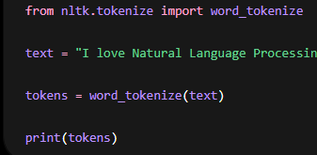
Output
['I', 'love', 'Natural', 'Language', 'Processing']

Fig 5: Stop words Removal Output
Code Used
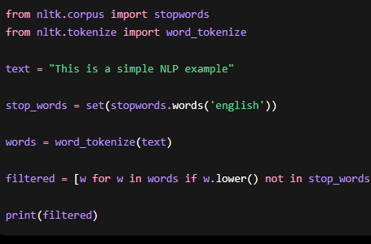
Output
['simple', 'NLP', 'example']

Fig 6: NLP Applications Research

Student Reflection
This week helped me understand the fundamentals of Natural Language Processing and its real-world applications. I learned how text preprocessing works through tokenization and stopword removal techniques. The experiments demonstrated how NLP systems prepare data before analysis and machine learning.

WEEK 2: N-GRAM MODELS AND POS TAGGING

Language Modeling and Sentence Structure Analysis
Bigram and trigram models were implemented to study word prediction and language modeling. POS tagging experiments were also performed to identify grammatical roles of words in sentences.

Required Evidence

Fig 1: Bigram Output
Code Used
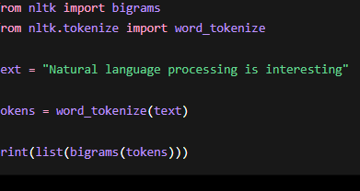

Fig 2: Trigram Output
Code Used
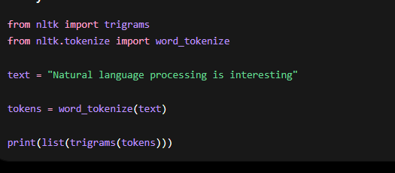
Output
[('Natural', 'language', 'processing'),
('language', 'processing', 'is'),
('processing', 'is', 'interesting')]

Fig 3: POS Tagging Example
Screenshot Placeholder:
(Insert screenshot showing POS tagging output)
Code Used
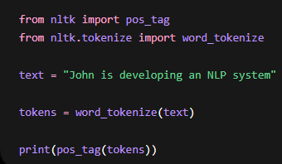
Output
[('John', 'NNP'),
('is', 'VBZ'),
('developing', 'VBG'),
('an', 'DT'),
('NLP', 'NNP'),
('system', 'NN')]

Student Reflection
This week improved my understanding of sentence structure analysis and language prediction models. I learned how N-grams help systems predict word sequences and how POS tagging identifies grammatical roles in text processing.

WEEK 3: HIDDEN MARKOV MODELS AND SEQUENCE LABELING

Sequence Prediction and Hidden State Analysis

Activities Performed
Experiments involving sequence labeling and Named Entity Recognition were performed. Simple sequence prediction models were tested to understand hidden state analysis in NLP systems.

Required Evidence

Fig 1: Sequence Labeling Code
Code Used
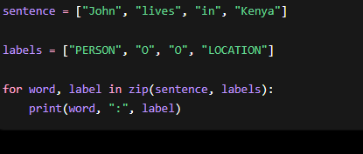
Output
John : PERSON
Kenya : LOCATION

Fig 2: Named Entity Recognition Example
Code Used
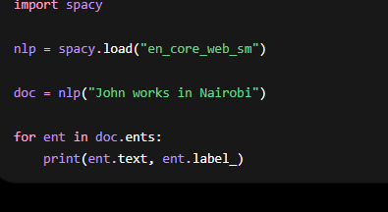Output
John PERSON
Nairobi GPE

Student Reflection
This week helped me understand how NLP systems identify entities and patterns from text. Named Entity Recognition is useful in AI assistants, search engines, and intelligent information extraction systems.

WEEK 4: SENTIMENT ANALYZER SYSTEM DEVELOPMENT

Development of Sentiment Analyzer System Using Python

Activities Performed
The Sentiment Analyzer System was developed using Flask and TextBlob. Frontend pages were created using HTML and CSS. The system accepts user text and classifies it as positive, negative, or neutral.

Required Evidence

Fig 1: Project Folder Structure
Screenshot Placeholder:
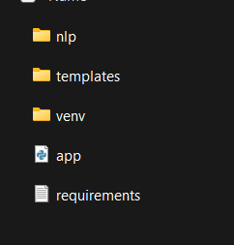
Folder Structure
sentiment_analyzer/
│
├── app.py
├── templates/
├── nlp/
├── database/

Fig 2: Flask Application Running
Screenshot Placeholder:
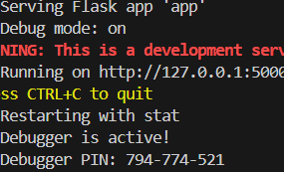
Command Used
python app.py
Output
Running on http://127.0.0.1:5000

Fig 3: Homepage Interface
Screenshot Placeholder:
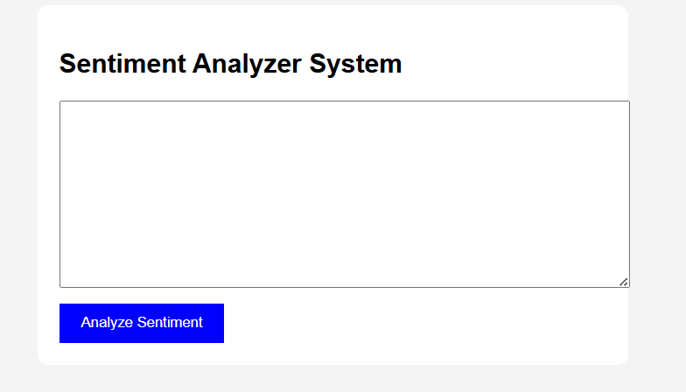

Fig 4: Sentiment Analysis Code
Code Used
from textblob import TextBlob

def analyze_sentiment(text):

analysis = TextBlob(text)

polarity = analysis.sentiment.polarity

if polarity > 0:
return "Positive"

elif polarity < 0:
return "Negative"

else:
return "Neutral"

Fig 5: Result Page Output
Screenshot Placeholder:
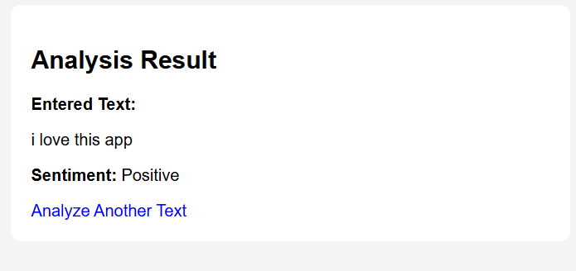
Example Output
Input:
I love this application

Output:
Positive 😊

Fig 6: System Wireframe
Screenshot Placeholder:
Inputs Wireframe

Analyze your text
Sentiment Analyzer system

Enter text here…..

⁂ Analyze sentiment

Output Wireframe

I love this app
Analyzed Results
Enter text…..
Positive
sentiment

Student Reflection
This week was important because I successfully developed a working NLP-based web application. I learned how Flask connects frontend and backend components and how TextBlob performs sentiment analysis automatically.

WEEK 5: DATABASE INTEGRATION AND TESTING

Database Integration and System Testing

Activities Performed
SQLite database was integrated into the system to store user text and sentiment results. The system was tested using different positive, negative, and neutral statements.

Required Evidence

Fig 1: SQLite Database Creation
Code Used
import sqlite3

conn = sqlite3.connect('sentiment.db')

print("Database created")

Fig 2: Database Table Structure
Code Used
CREATE TABLE sentiments(
id INTEGER PRIMARY KEY,
text TEXT,
result TEXT
)

Fig 3: Stored Results
Example Output
ID | Text | Result
1 | I love NLP | Positive
2 | This is bad | Negative

Student Reflection
This week improved my understanding of database integration in web applications. SQLite provided a lightweight and efficient way to store sentiment analysis results for future reference.

WEEK 6: USER INTERFACE IMPROVEMENT AND FINAL DEPLOYMENT

User Interface Enhancement and Final Testing

Activities Performed
The system interface was improved using color-coded results and better styling. Final debugging and testing were performed successfully.

Required Evidence
1: Improved Homepage
2: Color-Coded Results
3: Final Running System

Student Reflection
The final improvements enhanced the professionalism and usability of t

RECOMMENDATIONS
Improve sentiment accuracy using machine learning algorithms.
Add multilingual sentiment support.
Deploy the system online for real-world use.
Integrate graphical analytics dashboards.

CONCLUSION
The Sentiment Analyzer System was successfully developed using Python and Natural Language Processing techniques. The project demonstrated practical implementation of text analysis, sentiment classification, database integration, and web development concepts. WEEK 1: INTRODUCTION TO NLP AND APPLICATIONS

